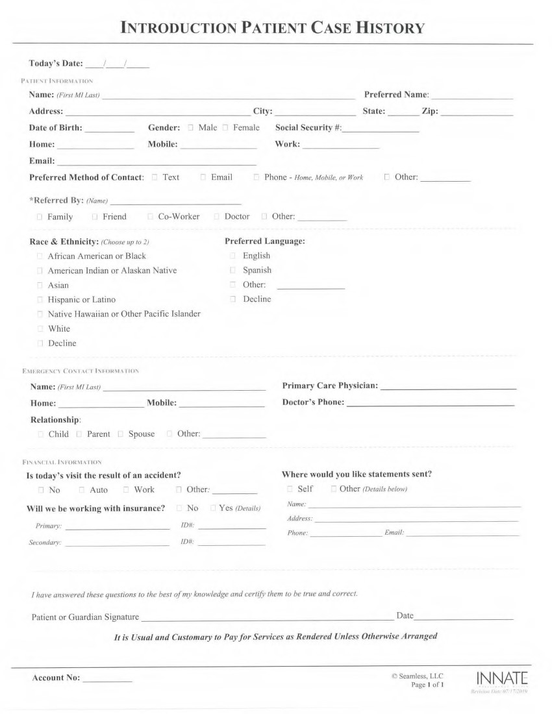

***PEDIATRIC CASE HISTORY***

History of current condition:

Describe Major Complaint: _______________________________________________________________________

Began when? ___/___/___ Describe how this began: _________________________________________________

_____________________________________________________________________________________________

Severity: None / Mild / Moderate / Severe / Very Severe

How frequent is the complaint present? Off and On / Constant

Does anything help make it better? ________________________________________________________________

Does anything make it worse? ____________________________________________________________________

Which daily activities are being affected by this? (Please describe) _______________________________________

_____________________________________________________________________________________________

For this CURRENT CONDITION, have you:

Received any other treatment? None / Chiropractor / Medical Doctor / PT / Massage / ER / Other: ___________

Had any previous surgery or intervention in this area? _________________________________________________

Taken any medications? OTC / Prescriptions _______________________________________________________

Had any diagnostic testing? X-rays / MRI / CT / Other: ______________ Where/When? _____________________

Describe any secondary complaint: _________________________________________________________________

***Medications****:* NONE / List: ________________________________________________

***Past Health History:***

Surgeries: NONE / Date, Type, and Reasons: ________________________________________________

Major injuries or traumas: NONE / Date and Description: ________________________________________________

Major hospitalizations: NONE / Date and Description: ________________________________________________

***Family Health History:***

List relevant major health problems of immediate relatives: ________________________________________________

Deaths in immediate family: ________________________________________________

***Prenatal History:***

Home / Birthing Center / Hospital

Birth Weight: _________ Birth Length: __________

Interventions: NONE / Forceps / Vacuum / C-section

Complications: NONE / ________________________________________________

Medications during pregnancy: NONE / ________________________________________________

***Feeding and Developmental History:***

Breastfed: ___ No ___ Yes

If yes, any challenges with latch? __ No __ Yes

Formula: ___ No ___ Yes

Food allergies or intolerances? NONE ________________________________________________

Sleep: Hours per night __________

Sleep Well? ___ No ___ Yes

Childhood diseases: ________________________________________________

Has child been vaccinated? ___ No ___ Yes Any adverse reactions? ___ No ___ Yes

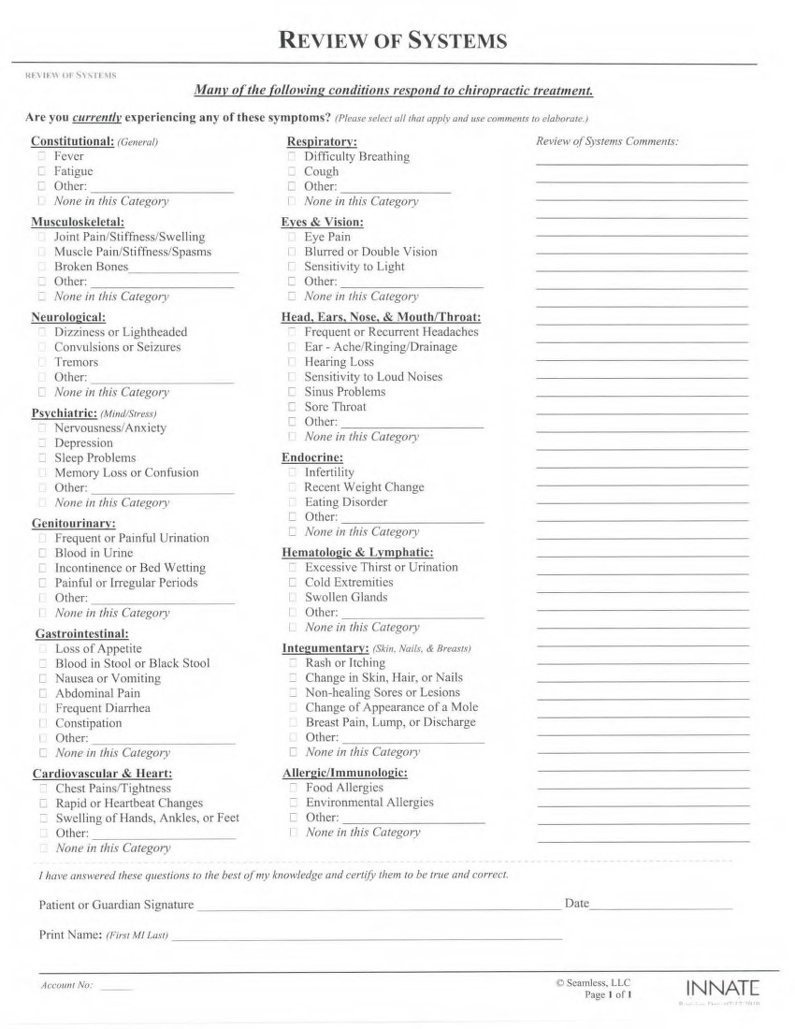

Before this office begins any health care operations we require you to read and sign this form stating that you understand the below item. If you refuse to sign this form the doctor reserves the right to refuse care.

**AUTHORIZATION:** By signing below you authorized this office/provider to complete a consultation and examination on the above.

**AUTHORIZATION FOR X-RAY WITH RELEASE:** By signing below you have declared, to the best of your knowledge, that there is no chance you are pregnant at this time. By signing below you have declared that you have no known limitations that would be contraindicated for an x-ray evaluation. By signing below you consent to the taking of x-rays if there is a determined need.

**ACKNOWLEDGMENT OF ASSIGNMENT OF BENEFITS:** By signing below you have acknowledged that you are fully responsible for all services rendered. By signing below you furthered acknowledge understanding that your health and accident insurance information policies are an arraignment between you and your carrier, and that you may be required to pay some or all of the fees charged to your account. By signing below you hereby assign benefits to paid directly to this office/provider by your third-party payer, e.g. insurance company, attorneys, etc. By signing below you agree that this is a non-rescindable agreement and failure to fulfill this obligation will be considered a breach of contract between you and this office.

**­CMS-1500 HEALTH INSURANCE CLAIM FORM**: By signing below you acknowledge and agree that the CMS-1500 Health Insurance Claim Form Box 12 and Box 13 will state “Signature on File”. Box 12 Reads as follows: “PATIENT’S OR AUTHORIZED PERSON’S SIGNATURE I authorize the release of any medical or other information necessary to process this claim. I also request payment of government benefits either to myself or to the party who accepts assignment below.” Box 13 Reads as follows: “INSURED’S OR AUTHORIZED PERSON’S SIGNATURE I authorize payment of medical benefits to the undersigned physician or supplier for services described below.”

**ACKNOWLEDGEMENT OF NOTICE OF PRIVACY PRACTICES:** We are very concerned with protecting your personnel health information. There may be times our office may need to contact you regarding office matters. By signing below you have authorized this office to contact you for office related matters in the following manner: phone-work-home or mobile, e-mail and regular mail. Messages may be left on an answering device/voicemail, or with the person answering your phone-home-work-mobile. Also in accordance with the Health Insurance Portability and Accountability act of 1996 (HIPAA), updated September 23, 2013, this office is obliges to supply you with a copy of the office privacy policies and procedures upon request. This document outlines the use and limitations of the disclosure of your personal health information and your rights as a patient. By signing below you have acknowledged that you have been offered a copy of this document.

**ACKNOWLEDGEMENT OF TREATMENT PLAN:** By signing below I acknowledge that, if accepted for care, I may be presented with a chiropractic treatment plan resulting in one or more of the following services: chiropractic adjustments, examinations, and supportive therapies and procedures.

**ACKNOWLEDGEMENT:** By signing below you have acknowledge that you understand and agree with the policies and procedures outlined in this TERMS of ACCEPTANCE form. By signing below you acknowledge and certify that all the information given to the office/provider in the INTAKE forms are a true and accurate to the best of you knowledge.

Signature of Patient: ______________________________________________________________

Signature of Parent or Guardian: ________________________________________________

***Consent for Chiropractic Services***

**By reading below I have been made aware:**

1. The process of delivering a “Chiropractic Adjustment (manipulation)” may be performed manually, with a table mechanism, or with an instrument to the vertebra(e) of the spine and/or associated structures (legs, arms etc.), often resulting in an audible pop or click sound;
2. As an addition to the Chiropractic Adjustment “Supportive Therapies and/or Procedures” may be applied by the chiropractor or by staff under the chiropractor’s direction or supervision incorporating the use of light, sound, vibration, electricity, traction, motion, bracing, nutritional advice, heat, or cold;
3. That on occasion some temporary soreness and/or stiffness may occur; less frequently aggravation of presenting symptoms or initiation of new symptoms; rarely bruising, swelling, even more rare separation/fracture; and extremely rare, nerve or vascular injury may occur in conjunction with the process of a Chiropractic Adjustment;
4. That the chiropractor has made no guarantee of a positive outcome from treatment.

**Additionally:**

1. I have been afforded ample opportunity for questions and answers.

**Therefore by signing below:**

**I consent** to the performance of the diagnostic and therapeutic procedures performed by the doctor and or staff under the direction and supervision of the office chiropractor(s) involved in my case;

**I consent** to the performance of other diagnostic and therapeutic procedures in the future that may be deemed reasonable and necessary by the doctor and or staff under the direction and supervision of the office chiropractor(s) involved in my case;

Patient Signature: ________________________________________

Parent/Guardian Signature:_________________________________

Witness Signature: ________________________________________